Part 1
- Put these astronomical objects in order of size from largest to smallest. (3)
Fill in the boxes in the correct order.
the Moon the Sun planets asteroids

largest |  |  |  |  | smallest

- Complete the sentences below.
There are of galaxies, each containing of Stars.
All of these galaxies make up the .
Our Sun is part of a called the . (5)
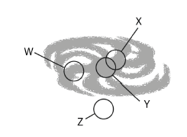
- (a) Which letter shows the approximate position of our
solar system in the galaxy? (1)

(b) What is the name given to planets which orbit
stars other than our Sun? (1)

(c) The age of our solar system is approximately: (1)
(tick the correct box).

4.5 billion years 45 million years

4.5 trillion years 450 thousand years

Part 2
- The Big Bang theory is the currently accepted theory for how the Universe began.
- Describe how the Universe began according to the Big Bang theory. (2)

……………………………………………………………………………………………………………………………………………………………………
……………………………………………………………………………………………………………………………………………………………………
……………………………………………………………………………………………………………………………………………………………………

- Name one piece of evidence that supports the Big Bang theory. (1)

……………………………………………………………………………………………………………………………………………………………………
……………………………………………………………………………………………………………………………………………………………………

- Observations of red shift of the supernova in distant galaxies suggest the galaxies at the extreme of our Universe are _____________.

Choose the correct word to complete the above sentence. (1)

accelerating cooling down getting bigger slowing down

- Only around 5% of the known Universe is made of visible matter. What two properties are thought to make up the other 95% of the universe? (2)

……………………………………………………………………………………………………………………………………………………………………
……………………………………………………………………………………………………………………………………………………………………

- Scientists have discovered over 3000 planets orbiting stars outside our solar system. Explain why probes have not been sent to see whether life exists on any of these planets? (2)
……………………………………………………………………………………………………………………………………………………………………
……………………………………………………………………………………………………………………………………………………………………
- The table shows the distances to three different galaxies, X, Y, and Z and the speed with which these galaxies are moving.
Galaxy | X | Y | Z
Distance (millions of light years) | 400 | 900 | 2200
Speed (km/s) | 7000 | 20 000 | 50 000

Describe the correlation shown by the data. (2)
……………………………………………………………………………………………………………………………………………………………………
……………………………………………………………………………………………………………………………………………………………………
……………………………………………………………………………………………………………………………………………………………………
- (a) Light from distant galaxies is red shifted. What does this tell us? (1)
……………………………………………………………………………………………………………………………………………………………………
……………………………………………………………………………………………………………………………………………………………………

(b) Light from some galaxies show a greater red shift. What does this tell us? (2)
……………………………………………………………………………………………………………………………………………………………………
……………………………………………………………………………………………………………………………………………………………………
……………………………………………………………………………………………………………………………………………………………………
(c) Circle the correct answer.

Red shift gives us evidence that the Universe is slowing down / expanding / getting hotter (1)

- The spectra below are from Star X. Underneath each Star X spectrum is the spectrum from a different element.
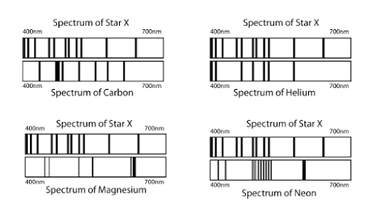

Which of the four elements is present in star X? (1)

……………………………………………………………………………………………………………………………………………………………………
……………………………………………………………………………………………………………………………………………………………………

- If a galaxy was moving towards the Earth, explain what the observed spectrum would look like. (3)

- The spectra below show light from two galaxies when viewed from Earth.

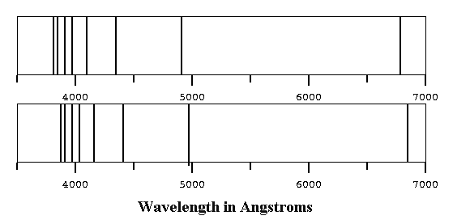
Near Galaxy

Distant Galaxy

Explain why the spectrum from the near galaxy looks different to that from the distant galaxy. (6)

……………………………………………………………………………………………………………………………………………………………………
……………………………………………………………………………………………………………………………………………………………………
……………………………………………………………………………………………………………………………………………………………………
……………………………………………………………………………………………………………………………………………………………………
……………………………………………………………………………………………………………………………………………………………………
……………………………………………………………………………………………………………………………………………………………………
……………………………………………………………………………………………………………………………………………………………………
……………………………………………………………………………………………………………………………………………………………………

- A star begins its life cycle as a nebula. Explain the structure of a nebula and the processes it goes through to become a star. (4)

……………………………………………………………………………………………………………………………………………………………………
……………………………………………………………………………………………………………………………………………………………………
……………………………………………………………………………………………………………………………………………………………………
……………………………………………………………………………………………………………………………………………………………………
……………………………………………………………………………………………………………………………………………………………………

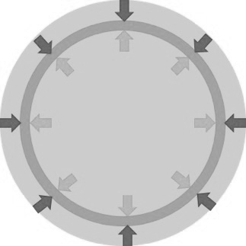
- The diagram shows the forces acting on a main sequence star.

- What do the two different arrows represent? (2)

White arrows represent

Black arrows represent

- What can you assume about these two forces in the main sequence star? (1)

……………………………………………………………………………………………………………………………………………………………………
……………………………………………………………………………………………………………………………………………………………………

- The diagram below shows nuclear fusion in a star.
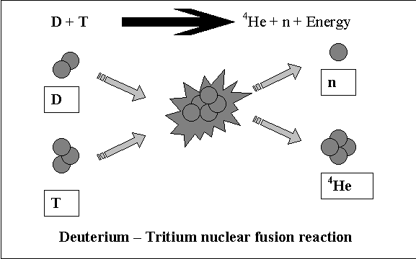

- What do the letters represent on the diagram? (3)

D =
T =
N =

- What else will be given off in this reaction? (1)

……………………………………………………………………………………………………………………………………………………………………
……………………………………………………………………………………………………………………………………………………………………

- The life cycle of a massive star is shown below.
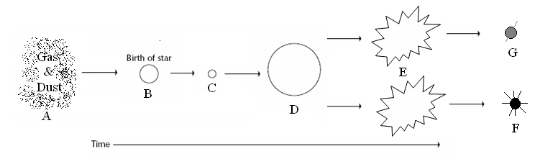

Label the stages of the life cycle shown by the letters A to G. (4)

……………………………………………………………………………………………………………………………………………………………………
……………………………………………………………………………………………………………………………………………………………………
……………………………………………………………………………………………………………………………………………………………………
……………………………………………………………………………………………………………………………………………………………………
……………………………………………………………………………………………………………………………………………………………………
……………………………………………………………………………………………………………………………………………………………………

16. The sun is in its main sequence stage. What will happen to the sun as the hydrogen begins to run out? (2)

……………………………………………………………………………………………………………………………………………………………………
……………………………………………………………………………………………………………………………………………………………………
……………………………………………………………………………………………………………………………………………………………………

17. Explain why small stars remain in their main sequence stage much longer than very big stars. (2)

……………………………………………………………………………………………………………………………………………………………………
……………………………………………………………………………………………………………………………………………………………………
……………………………………………………………………………………………………………………………………………………………………

18. The diagram below shows how larger elements could be made in a star. In the space below write a
reaction to show the process described. (3)
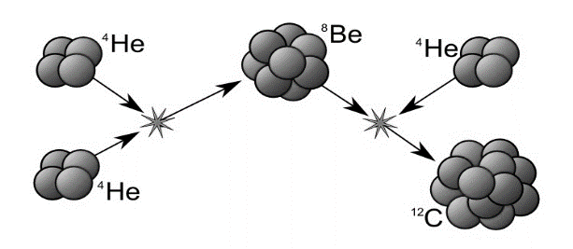

……………………………………………………………………………………………………………………………………………………………………
……………………………………………………………………………………………………………………………………………………………………
……………………………………………………………………………………………………………………………………………………………………
……………………………………………………………………………………………………………………………………………………………………
……………………………………………………………………………………………………………………………………………………………………

19. Elements bigger than iron cannot be produced in fusion reactions in stars.
Explain how the larger elements are created and dispersed in the Universe. (3)

……………………………………………………………………………………………………………………………………………………………………
……………………………………………………………………………………………………………………………………………………………………
……………………………………………………………………………………………………………………………………………………………………
……………………………………………………………………………………………………………………………………………………………………
……………………………………………………………………………………………………………………………………………………………………

